|  |
| --- |
| **Fire Evacuation Procedure - LACOCK VILLAGE HALL**  **This evacuation guidance must the read, understood and complied with by the named person for each booking.**  **1. Raise the Alarm**  If you discover a fire, immediately raise the alarm by operating the nearest ‘Break Glass’  call point.  Dial 999 and ask for the Fire Brigade, tell them your location.  **Lacock Village Hall, East Street, Lacock SN15 2LF**  Make sure that all members of your party have reached the fire assembly point. We recommend that for larger groups, you should re-assemble on High Street outside Red Lion, one person should remain outside the hall to flag down the fire tender and prevents persons entering the hall.  **2**  **. Putting out a Fire**  If the fire is a small, localised fire and you feel confident to do so without putting  your safety at risk, attempt to tackle the fire using the correct fire extinguisher or  the fire blanket in the kitchen.  **Extinguisher**  **Location**  **Type of fire**  C02  Kitchen  Electrical fires  Water  Main hall and Manor Roomç√  Combustible material  Foam  Combustible material  Water  Front lobby  Combustible material  **3**  **. Fire Escape Routes**  Follow the nearest ‘Green Running Man’ fire exit signs which will direct you to the  nearest available exit.  Do not stop for personal belongings. Ensure that those around you also  evacuation the premises.  Close doors and windows, if safe to do so.  **The Fire Assembly Point is: High Street outside Red Lion**  **l**  **. Make sure your party is safe**  **4**  **5. Personal Emergency Evacuation Plans (PEEPS)**  If any members of the party have limited mobility, if possible use the main entrance to exit. the building and provide assistance to help them leave safely. If this route is not accessible, you may need to assist them exiting via the door adjacent to the stage in the main hall as there is a single step. Two people may be required to assist with a wheel chair user. |

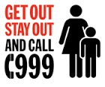



**6. Injured Person (s)**



If any members of your party are injured, grab the first aid kit in the kitchen and

take it to the Fire Assembly point.

**7. Wait for further instruction from the Fire Brigade**

On arrival brief the Fire Brigade about the event.

Do not re-enter the building until informed it is safe to do so by the Fire Brigade. Follow

instructions given by the Fire Brigade; they are the fire safety experts

and will have one objective – to protect you from fire and keep you safe.

**8. False Alarms**

From time to time the fire control panel may be activated by accident or has a

false alarm reading, please read the instructions on the alarm panel on how to

silence it and let us know by emailing

[lacockvhbooking@gmail.com](mailto:lacockvhbooking@gmail.com). so we can fix it.

**9. Let us know**

In the event of a real incident let us know as soon as possible by dialling one of

the Village Hall Committee members contact details.

Jess Trought 07921 068494

Jane Durrant 07739 750630

Heather Shepherd 007714 152118

|  |
| --- |
|  |

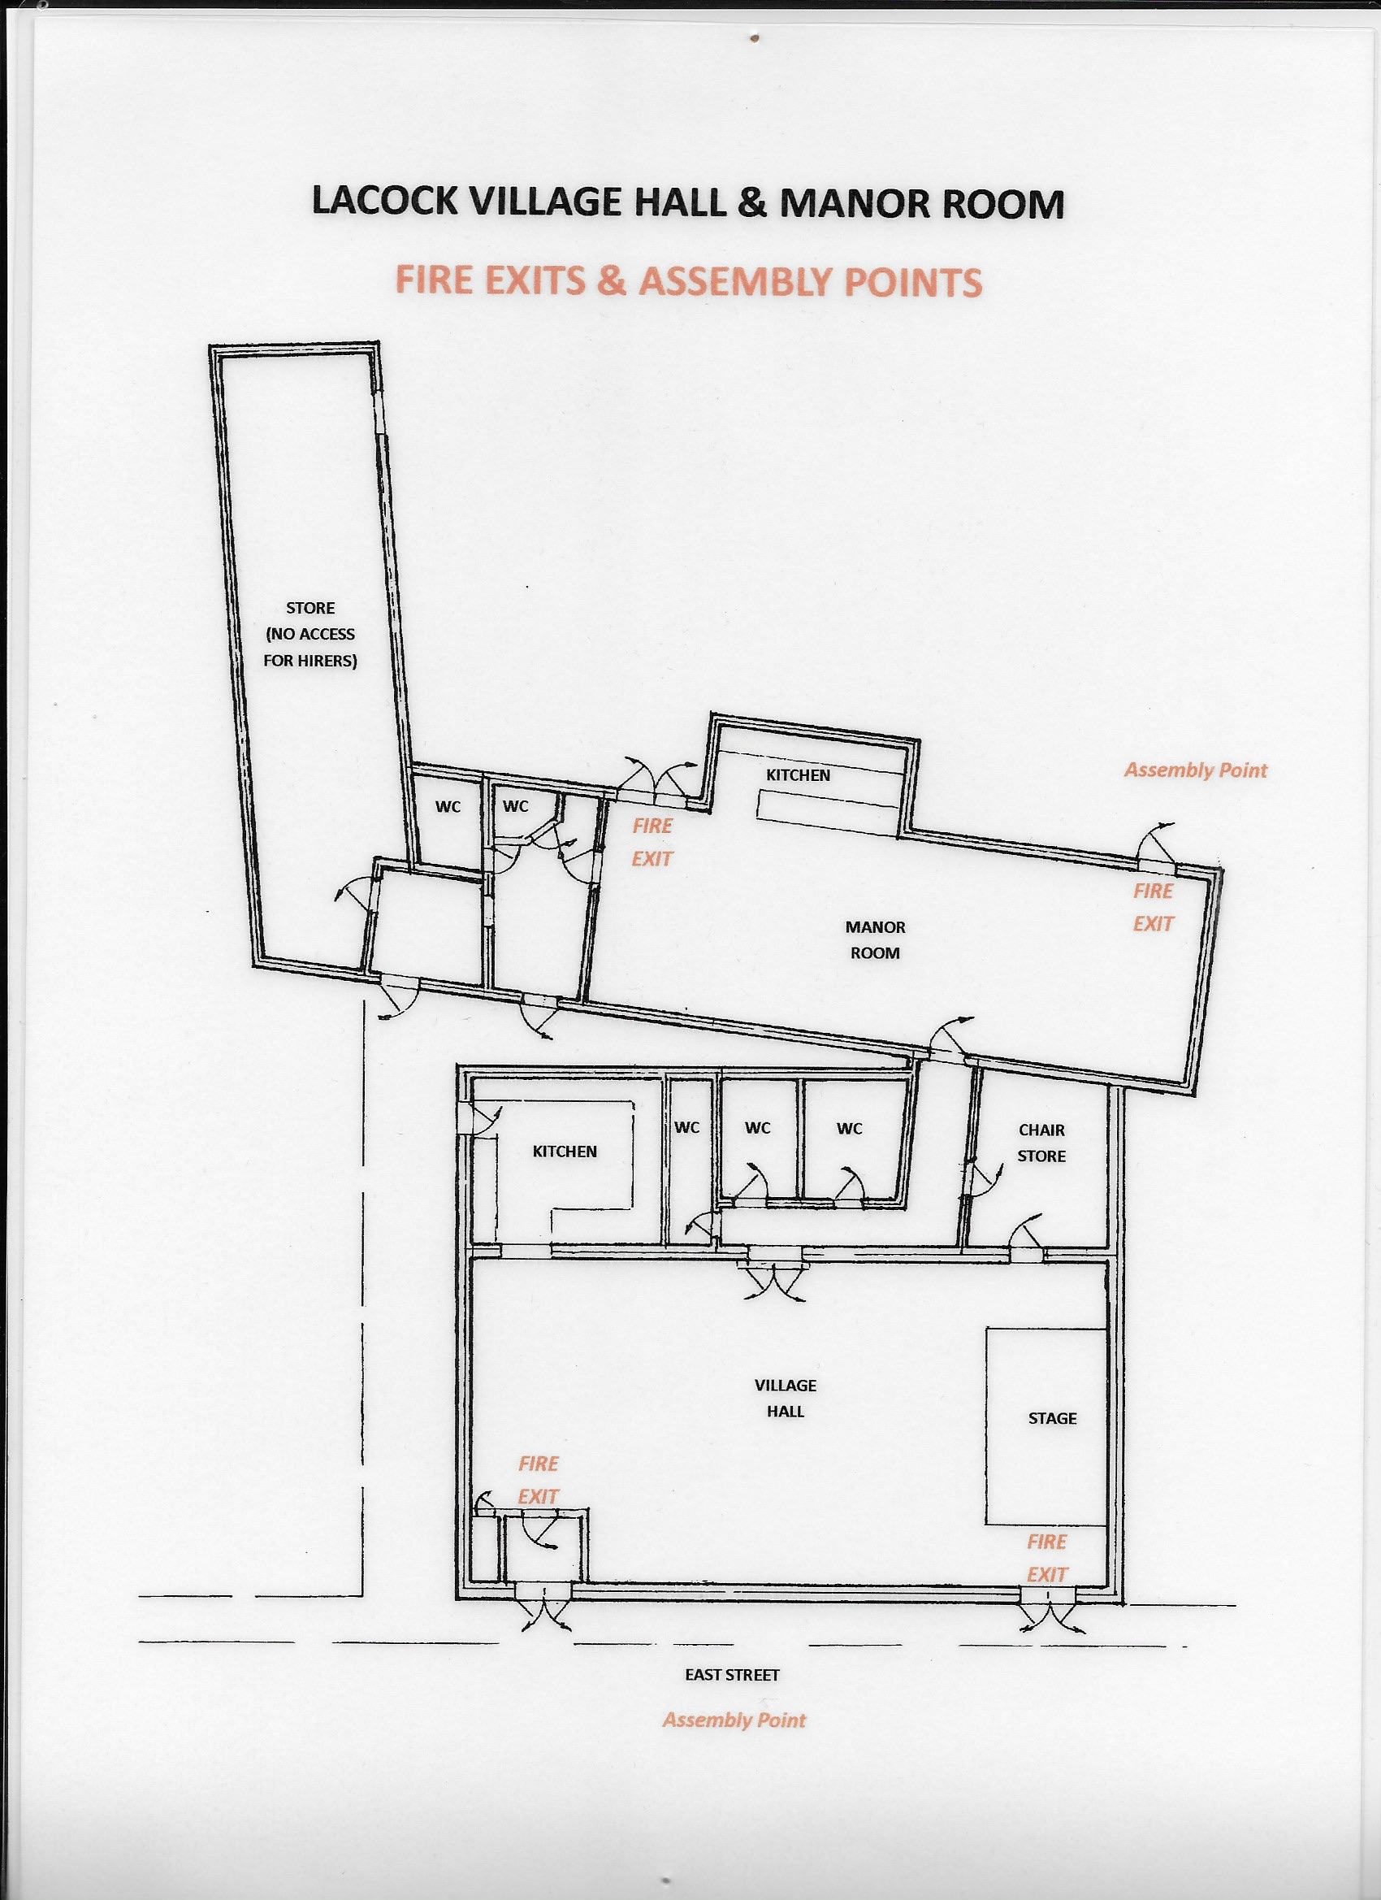

FIRE

EXIT

FIRE

EXIT

KEY

Powder Fire Extinguisher

Foam Fire Extinguisher

First Aid Box

Fire Alarm Panel

Zone 1 Main Hall & Kitchen

Zone 2 Manor Room

Zone 3 Rear Store Room